- Print T111 Eagle Scout Checklist & Eagle Project Concept Development Worksheet (optional) from troop website.
Troop 111 Eagle Scout Checklist
2022
- Read over and complete worksheet.

- Download Eagle Scout Service Project Workbook from troop website

- Start progress log. (A spreadsheet logging your hours worked, tasks completed).

- Develop a concept by discussing your ideas with the organization that you would like to do the project for, using the guidelines in the Project Workbook and the Concept Development Worksheet.
- Be sure the organization approves of your concept.

- Download Eagle Project Proposal from Troop Website
- Complete Eagle Project Proposal
- Schedule a meeting with the Eagle Project Coach, Scoutmaster & Advancement Chair to review the proposal before submitting.

- Have Scoutmaster and Committee Chair sign your Eagle Project Proposal.

- Contact the GSC Eagle Board to schedule a project proposal meeting
- Notify Eagle Coach, Scoutmaster & Committee chair of date

- Attend project proposal meeting.

- Once the proposal has been approved by the Eagle Board, complete the Project Final Plan with as much detail as needed to successfully carry out the project.
- If the proposal is not approved, contact the Eagle Coach for suggestions for improvement
- Select date for your project then coordinate with Eagle Project Coach and Scoutmaster.
- Contact Committee Chair to put project date on Troop calendar.
- Order plaque to be displayed on your project.
- Purchase Online or at local shop such as: Stellar Signs & Graphics.
- Here’s an example
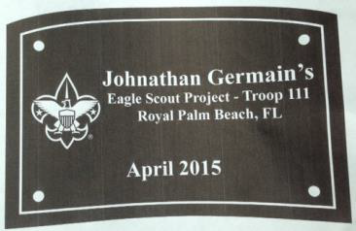
- Meet with Eagle Project Coach for comments on your Final Plan –record notes in the Eagle Project Coach comments section.
- Prepare signup sheets
- Request Committee Chair to add project to Scoutpay
- Have Scribe sent out email notification
- Complete project.
- Get final signature from beneficiary.
- Prepare certificates for volunteers
- Write thank you letters
- Finish write up and add photos from your project day.
Troop 111 Eagle Scout Checklist
- Complete any incomplete merit badges
- Prepare your Eagle Scout Application
- Create a power point presentation detailing your project & photos
- Prepare your Eagle Scout Binder including:
1) Requirement 6 on the application – your statement of ambitions and life purpose.
2) Your fully completed Eagle Scout Service Project Workbook.
3) Copies of all honors and awards.
- Have Eagle Project Coach review your application and Eagle Scout Binder with you for accuracy.
- Schedule Scoutmaster Conference.
- Bring application, binder, and Scouts BSA Handbook to the conference.
- Obtain all signatures on Eagle Scout Application.
- Submit Eagle Scout Application to the Council Office.
- Schedule a mock / practice Eagle Board of Review with Advancement Chair.
- Wear Class A including merit badge sash.
- Have your scout book, Eagle binder and Power Point Presentation
- Once you receive your Eagle Board of Review date notify your Eagle Coach, Scoutmaster & Advancement Chair.

