Troop 111 Job Description
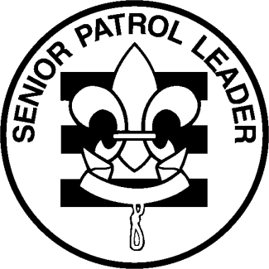
Job Title: Senior Patrol Leader

Level: 1
Reports to: Scoutmaster
Supervised by: Mr. McNally

Job Duties:

- Runs all troop meetings, events, activities and the Annual Program Planning Conference.
- Coordinates all the responsibilities of the Shaman Patrol, encouraging teamwork among members.
- Prepares the agenda for and runs the PLC monthly. Informs Shaman Patrol in advance of their part / reports to the PLC.
- Ensures that each troop meeting and activity has a detailed plan and that assignments are communicated well in advance of each event.
- Ensures that all supplies / equipment are on hand to complete each activity.
- Calls each Shaman Patrol member prior to each event to remind of responsibilities.
- Reports at least 20 minutes early to each troop meeting to go over last minute details.
- Is the last to leave each troop meeting to supervise clean-up and evaluate each event.
- Oversees all duty rosters, allocation of responsibilities.
- Oversees all duty rosters, allocation of responsibilities.
- With the Shaman Patrol and with advice and counsel of the Scoutmaster, appoints other
troop junior leaders.
- Assists the Scoutmaster / Assistant Scoutmaster with Junior Leader Training.
- Serves as a role model to fellow scouts.
- Sets good example by enthusiastically wearing the uniform correctly, showing Scout Spirit and living the Scout Oath and Law.

As Senior Patrol Leader, I promise to do my best to fulfill the requirements of this position during my term. I understand that my performance in this position will be evaluated by The Shaman Patrol and the adult leaders on the basis of my ability to complete the job based on the description above.

Scout Signature: ___________________________________________________ Date: ____________________

Parent Signature: __________________________________________________ Date: ____________________
Troop 111 Job Description
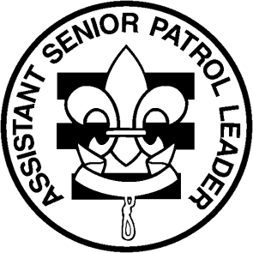

Job Title: Assistant Senior Patrol Leader

Level: 1
Reports to: Senior Patrol Leader / Shaman Patrol
Supervised by: Mr. McNally

Job Duties:

- Serves in place of the SPL if the SPL is not in attendance at a meeting or event.
- Assists the SPL in running all troop meetings, events, activities and the Annual Program Planning Conference.
- Assists the SPL in coordinating all the responsibilities of the Shaman Patrol, encouraging teamwork among members and providing training as needed.
- Gives input on the preparation of the agenda for the PLC monthly.
- Calls Patrol Leaders prior to each event to remind them to contact their patrol and of any responsibilities their patrol may have.
- Assists the SPL to ensure that each troop meeting and activity has a detailed plan and that assignments are communicated well in advance of each event.
- Reports at least 20 minutes early to each troop meeting to go over last minute details.
- Stays with the SPL at the end of the meeting to supervise clean-up and evaluate each event.

- Helps to oversee all duty rosters, allocation of responsibilities.
- Assists the SPL / Scoutmaster / Assistant Scoutmaster with Junior Leader Training.
- Serves as a role model to fellow scouts.
- Sets good example by enthusiastically wearing the uniform correctly, showing Scout Spirit and living the Scout Oath and Law.

As Assistant Senior Patrol Leader, I promise to do my best to fulfill the requirements of this position during my term. I understand that my performance in this position will be evaluated by The Shaman Patrol and the adult leaders on the basis of my ability to complete the job based on the description above.

Scout Signature: __________________________________________________ Date: ____________________

Parent Signature: _________________________________________________ Date: ____________________
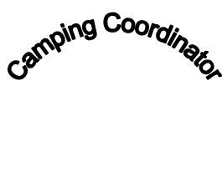
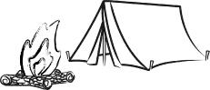
Troop 111 Job Description

Job Title: Troop Camping Coordinator

Level: 1
Reports to: Senior Patrol Leader / Shaman Patrol
Supervised by: Mr. McNally

Job Duties:

Prepare Troop Duty Roster for each campout, bringing it to the Patrol Meeting prior to each campout and informing the patrols of their duties.
Plan campout agendas based on suggestions from the PLC, distribute to PLs and bring copy to the campout.
Working with the Troop Grubmaster, bring menu specifications ideas to the PLC's (and then giving that info out or taking a vote if more than one idea is presented).
Approve all patrol menus, patrol duty rosters and campout planners at the patrol meeting prior to the campout.
Bring information about the actual camping area to the PLCs and distribute that info.
Plan all camping and weekly troop games.
Ensure that a campfire MC is in place and that the campfire is well planned.
Ensure that the Troop Chaplain Aide has the worship service.
Assists with the planning, coordination and preparation for summer camp.
Sets good example by enthusiastically wearing the uniform correctly, showing Scout Spirit and living the Scout Oath and Law.

As Troop Camping Coordinator, I promise to do my best to fulfill the requirements of this position during my term. I understand that my performance in this position will be evaluated by The Shaman Patrol and the adult leaders on the basis of my ability to complete the job based on the description above.

Scout Signature: __________________________________________________ Date: ____________________

Parent Signature: _________________________________________________ Date: ____________________

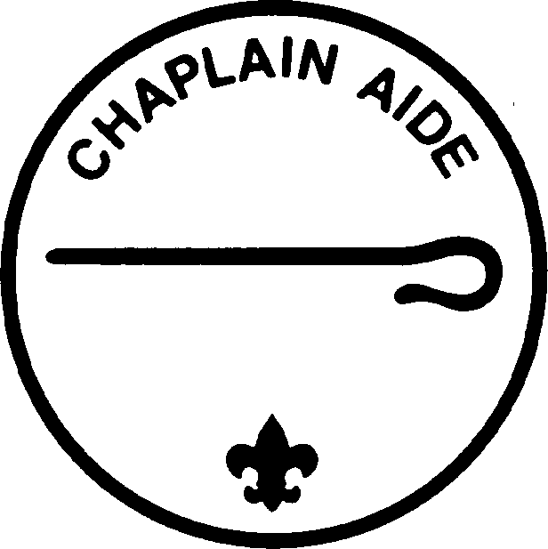
Troop 111 Job Description

Job Title: Troop Chaplain Aide

Level: 1
Reports to: Senior Patrol Leader / Shaman Patrol
Supervised by: Mr. McNally

Job Duties:

- Plan and lead non-denominational services at all Troop meetings and outings (opening prayers, closing prayers, blessings.)
- Ensures that religious holidays are considered during planning.
- Prepares a non-denominational religious service agenda and pamphlet for all troop campouts. Presides over religious service. In the event that the Troop Chaplain Aide is unable to attend an outing, he is responsible for making arrangements with another scout to lead the service.
- Maintains book of prayers, hymns, adding at least 10 items during your tenure. Adds each religious service pamphlet to the book when completed.
- Informs Scouts about the religious emblems program for their faith.
- Acts as the Goodwill Ambassador for the troop, for example coordinating sending get well cards if a member is ill or letting the Troop know of opportunities to help others in need.
- Sets good example by enthusiastically wearing the uniform correctly, showing Scout Spirit and living the Scout Oath and Law.

As Troop Chaplain Aide, I promise to do my best to fulfill the requirements of this position during my term. I understand that my performance in this position will be evaluated by The Shaman Patrol and the adult leaders on the basis of my ability to complete the job based on the description above.

Scout Signature: __________________________________________________ Date: ____________________

Parent Signature: _________________________________________________ Date: ____________________

Troop 111 Job Description

Job Title: OA Rep

Level: 1
Reports to: Senior Patrol Leader / Shaman Patrol
Supervised by: Mr. McNally

Job Duties:

Promotes information about and participation in the Order of the Arrow.

Provides information about all upcoming OA events and elections.

Maintains OA phone list to include troop OA members, chapter and lodge leaders.

Encourages fellow Arrowmen to take OA Leadership roles.

Helps fellow Arrowmen achieve Brotherhood.

Promotes both short-term and long-term camping events.

- Sets good example by enthusiastically wearing the uniform correctly, showing Scout Spirit and living the Scout Oath and Law.

As OA Rep, I promise to do my best to fulfill the requirements of this position during my term. I understand that my performance in this position will be evaluated by The Shaman Patrol and the adult leaders on the basis of my ability to complete the job based on the description above.

Scout Signature: __________________________________________________ Date: ____________________

Parent Signature: _________________________________________________ Date: ____________________

Troop 111 Job Description

Job Title: Troop Quartermaster

Level: 1
Reports to: Senior Patrol Leader / Shaman Patrol
Supervised by: Mr. Estevez

Job Duties:

- Maintains list of materials to be stored in troop trailer for campsite set-up (first aid kit, rope, garbage bags, ax, 5-gallon buckets, etc.). Checks inventory periodically and advises Troop Equipment Chairperson about needed items
- Ensures that the troop flags are at every troop event (or arranges them to be brought if not in attendance).

- Encourages patrols to bring their flags to troop events.

- Ensures that the proper cleaning supplies are at each troop meeting. If supplies are needed, he should let the Troop Equipment Chairperson know what is needed.
- Checks all equipment in and out through the patrol quartermasters, maintaining an accurate, dated list. Oversees Patrol Quartermasters and contacts them if equipment is not returned.

- Ensures that all equipment is clean and in good repair as it is checked in.

- Supervises the cleaning and organizing of the troop trailer after each campout.

- Makes suggestions for new or replacement items.

- Sets good example by enthusiastically wearing the uniform correctly, showing Scout Spirit and living the Scout Oath and Law.

As Troop Quartermaster, I promise to do my best to fulfill the requirements of this position during my term. I understand that my performance in this position will be evaluated by The Shaman Patrol and the adult leaders on the basis of my ability to complete the job based on the description above.

Scout Signature: __________________________________________________ Date: ____________________

Parent Signature: _________________________________________________ Date: ____________________

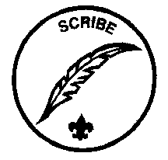
Troop 111 Job Description

Job Title: Troop Scribe

Level: 1
Reports to: Senior Patrol Leader / Shaman Patrol
Supervised by: Mr. McNally

Job Duties:

- Takes and distributes minutes at each PLC.

- Takes attendance at EVERY event, including troop meetings and submits attendance to committee
Chairperson. He may have patrols do their own attendance but he is responsible for collecting it.

- Brings blank Honor Patrol Sheets to each meeting.

- Sends email reminders about upcoming events at least 2 days prior to the event.

- Prepares white board for each meeting.

- Contacts the Advancement Chairperson to schedule Boards of Review and contacts Scout to let him know when the Board of Review will be and what to bring for it.

- Oversees Patrol Scribes.

- Conducts Honor Patrol, uniform inspections and conducts raffle. Purchase items for raffle.

- Sets good example by enthusiastically wearing the uniform correctly, showing Scout Spirit and living the Scout Oath and Law.

As Troop Scribe, I promise to do my best to fulfill the requirements of this position during my term. I understand that my performance in this position will be evaluated by The Shaman Patrol and the adult leaders on the basis of my ability to complete the job based on the description above.

Scout Signature: __________________________________________________ Date: ____________________

Parent Signature: _________________________________________________ Date: ____________________

Troop 111 Job Description

Job Title: Troop Cheermaster

Level: 2
Reports to: Senior Patrol Leader / Shaman Patrol
Supervised by: Mr. McNally

Job Duties:

- Encourages spirit within the Troop.

- Has songs, skits, cheers, prepared for each meeting / outing as specified at the PLC.

- Makes sure each patrol has a flag and a cheer.

- Maintains a “Cheer Book” which includes skits, songs, and cheers. Adds at least 10 items to the Cheer Book during his tenure.

- Gives scouts who are assigned to do skits, songs, ideas about where to look (on-line, books, etc.).

- Assists the Master of Ceremonies at all campfires or as needed.

- Heads up the committee for summer camp spirit (and themes)

- Sets good example by enthusiastically wearing the uniform correctly, showing Scout Spirit and living the Scout Oath and Law.

As Troop Cheermaster, I promise to do my best to fulfill the requirements of this position during my term. I understand that my performance in this position will be evaluated by The Shaman Patrol and the adult leaders on the basis of my ability to complete the job based on the description above.

Scout Signature: __________________________________________________ Date: ____________________

Parent Signature: _________________________________________________ Date: ____________________

Troop 111 Job Description

Job Title: Den Chief

Level: 2
Reports to: Senior Patrol Leader / Shaman Patrol
Supervised by: Mr. McNally

Job Duties:

Is assigned to a den and assists at den meetings, pack meetings and other activities the den does. Must keep a log to include date, time, and activity to be signed by the Den Leader. Participation must be at a 75% level or higher to receive credit for the position.

Assists the Den Leader as asked.

Is a friend to the scouts in the den and encourages them to do their best.

Is a great role model.

Encourages Cub Scouts to join a Boy Scout Troop upon graduation.

Keeps the Troop informed about any needs the pack might have.

- Sets good example by enthusiastically wearing the uniform correctly, showing Scout Spirit and living the Scout Oath and Law.

As Den Chief, I promise to do my best to fulfill the requirements of this position during my term. I understand that my performance in this position will be evaluated by The Shaman Patrol and the adult leaders on the basis of my ability to complete the job based on the description above.

Scout Signature: __________________________________________________ Date: ____________________

Parent Signature: _________________________________________________ Date: ____________________
Troop 111 Job Description
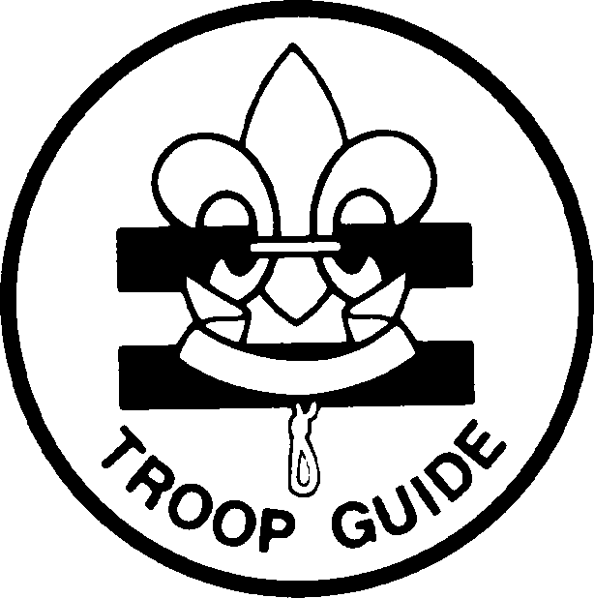

Job Title: Troop Guide / Instructor

Level: 2
Reports to: Senior Patrol Leader / Shaman Patrol
Supervised by: Dr. Rice

Job Duties:

Introduces the new Scouts to Troop Operations.

Is a member of the New Scout Patrol and is a friend and mentor.

Guides new Scouts through their first months of Scouting.

Teaches basic Scout Skills (first aid, cooking, knots, etc.) and ensures that equipment and materials that are needed to teach those skills are on hand.

Works with the PLC to ensure that new scout skills are featured at all troop outings.

Coaches the patrol leader / assistant patrol leader of the New Scout Patrol on his duties and attends PLCs with him to assist him.

Helps the new scouts feel like part of the troop and helps other troop members to make the new scouts feel welcome.

Talks with the new scouts about summer camp and encourages them to attend.

Sets good example by enthusiastically wearing the uniform correctly, showing Scout Spirit and living the Scout Oath and Law.

As Troop Guide, I promise to do my best to fulfill the requirements of this position during my term. I understand that my performance in this position will be evaluated by The Shaman Patrol and the adult leaders on the basis of my ability to complete the job based on the description above.

Scout Signature: __________________________________________________ Date: ____________________

Parent Signature: _________________________________________________ Date: ____________________
Troop 111 Job Description
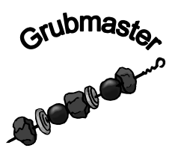
Job Title: Troop Grubmaster

Level: 2
Reports to: Senior Patrol Leader / Shaman Patrol
Supervised by: Mr. McNally

Job Duties:

Maintains a troop cookbook to include recipes and menu ideas. Adds at least 8 new recipes to book during the term.

If he notes that anything is wrong with the troop cooking equipment, he should notify the Troop Quartermaster.

Assists with planning / preparation of troop cracker barrels or special tastings.

May set “theme” for cooking at a campout (i.e. foil dinner, Dutch oven).

May be asked to judge cooking contests.

Plans and purchases troop meeting snacks, (purchases within budget – from petty cash).

Ensures that there is a hydration officer at all outdoor troop events.

Sets good example by enthusiastically wearing the uniform correctly, showing Scout Spirit and living the Scout Oath and Law.

As Troop Grubmaster, I promise to do my best to fulfill the requirements of this position during my term. I understand that my performance in this position will be evaluated by The Shaman Patrol and the adult leaders on the basis of my ability to complete the job based on the description above.

Scout Signature: __________________________________________________ Date: ____________________

Parent Signature: _________________________________________________ Date: ____________________
Troop 111 Job Description
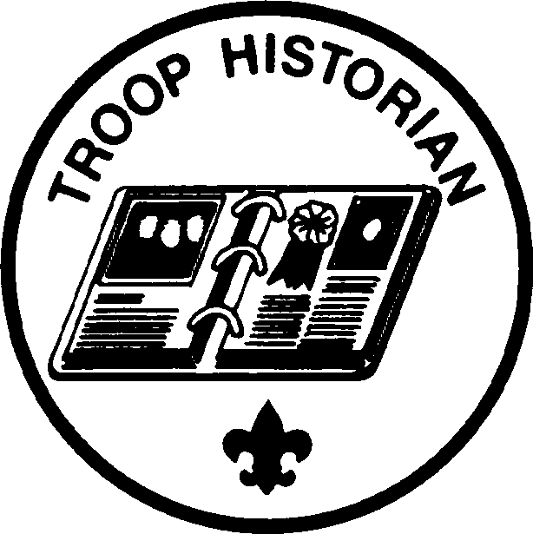

Job Title: Troop Historian

Level: 2
Reports to: Senior Patrol Leader / Shaman Patrol
Supervised by: Dr. Rice

Job Duties:

Takes pictures at each campout and all scout functions. Share photos with Webmaster. Print a sample of photos, place in the troop photo album, and label the event, date and scout names.

Maintain a binder of all troop newsletters and Court of Honor Programs.

Maintain a binder of scouting news articles, a brief written history (journal style) of interesting events to include troop awards and recognitions, and a list of T111 Eagle Scouts to include names, dates and a brief description of their Eagle Project.

Set up binders and photo albums for viewing at the Troop Court of Honor.

Find and share at least one article or item per month on something historical or interesting about scouting for publication in the newsletter.

Keep troop camera in good working order and request needed supplies (4 x 6 photo paper, printer ink, CDs, binder pages) from Supervisor.

Work with Troop Webmaster to publish Troop photos for at least one event per month to the troop website & CAFCI newsletter

Sets good example by enthusiastically wearing the uniform correctly, showing Scout Spirit and living the Scout Oath and Law

As Troop Historian, I promise to do my best to fulfill the requirements of this position during my term. I understand that my performance in this position will be evaluated by The Shaman Patrol and the adult leaders on the basis of my ability to complete the job based on the description above.

Scout Signature: __________________________________________________ Date: ____________________

Parent Signature: _________________________________________________ Date: ____________________

Troop 111 Job Description

Job Title: Troop Librarian

Level: 2
Reports to: Senior Patrol Leader / Shaman Patrol
Supervised by: Dr. Rice

Job Duties:

Keeps a library of merit badge pamphlets and other Troop materials available for check out and use by Troop members and leaders.

Brings library to each troop meeting and has a system for checking books in and out of the library, following up on overdue materials.

Keeps an inventory of all library materials.

Actively seeks materials to be added to the library (from scouts / leaders who may not need them any more). Should add at least 5 new items to the library during his term.

Collect and catalog pamphlets, articles, etc. of places or trips the Troop has gone on or could go on, adding 3 items to the collection during his term.

Work with the Troop Webmaster to keep the online Troop Library records accurate.

Sets good example by enthusiastically wearing the uniform correctly, showing Scout Spirit and living the Scout Oath and Law.

As Troop Librarian, I promise to do my best to fulfill the requirements of this position during my term. I understand that my performance in this position will be evaluated by The Shaman Patrol and the adult leaders on the basis of my ability to complete the job based on the description above.

Scout Signature: __________________________________________________ Date: ____________________

Parent Signature: _________________________________________________ Date: ____________________

Troop 111 Job Description
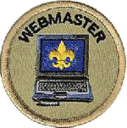
Job Title: Troop Webmaster

Level: 2
Reports to: Patrol Leader
Supervised by: Mrs. Cabrera

Job Duties:

- Responsible for maintaining the troop’s on-line calendar in a timely manner.
- Work with Scoutmaster and Troop Committee Chair on website content.
- Publish Troop photos for at least one event per month to the troop website.
- Sets good example by enthusiastically wearing the uniform correctly, showing Scout Spirit and living the Scout Oath and Law.

As Troop Webmaster, I promise to do my best to fulfill the requirements of this position during my term. I understand that my performance in this position will be evaluated by The Shaman Patrol and the adult leaders on the basis of my ability to complete the job based on the description above.

Scout Signature: __________________________________________________ Date: ____________________

Parent Signature: _________________________________________________ Date: ____________________

Troop 111 Job Description
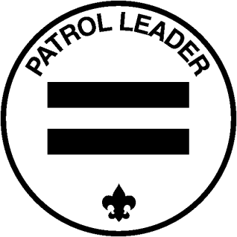

Job Title: Patrol Leader

Level: 2
Reports to: Senior Patrol Leader
Supervised by: Mr. McNally

Job Duties:

Supervises the other patrol members ensuring they are doing their assigned jobs.

Represents the patrol at all PLC’s and Program Planning events. If unable to attend, arranges to have another patrol member attend.

Takes patrol ideas and concerns to the PLC for discussion.

Helps the patrol prepare for all of its activities and responsibilities.

Calls all patrol members prior to each event and keeps them all informed and ensures the scribe sends email communications.

Encourages patrol members to abide by the T111 Code of Conduct.

Encourages patrol pride and spirit.

Encourages patrol members to advance.

Plans and steers patrol meetings and activities.

Sets good example by enthusiastically wearing the uniform correctly, showing Scout Spirit and living the Scout Oath and Law.

As Patrol Leader, I promise to do my best to fulfill the requirements of this position during my term. I understand that my performance in this position will be evaluated by The Shaman Patrol and the adult leaders on the basis of my ability to complete the job based on the description above.

Scout Signature: __________________________________________________ Date: ____________________

Parent Signature: _________________________________________________ Date: ____________________

Troop 111 Job Description
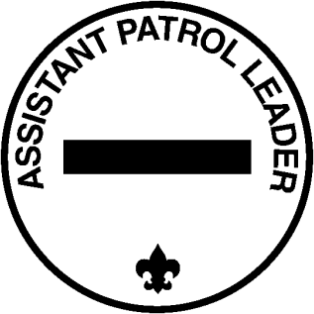

Job Title: Assistant Patrol Leader

Level: 3
Reports to: Patrol Leader
Supervised by: Mr. McNally

Job Duties:

Leads the patrol in the Patrol Leaders absence.

Helps the patrol get ready for all troop activities.

Represents the patrol at PLC’s and Program Planning events.

Helps the Patrol Leader keep all the members informed.

Helps the Patrol Leader to encourage patrol members to abide by the T111 Code of Conduct.

Lends a helping hand in leading patrol activities and building patrol spirit.

Sets good example by enthusiastically wearing the uniform correctly, showing Scout Spirit and living the Scout Oath and Law.

As Assistant Patrol Leader, I promise to do my best to fulfill the requirements of this position during my term. I understand that my performance in this position will be evaluated by The Shaman Patrol and the adult leaders on the basis of my ability to complete the job based on the description above.

Scout Signature: __________________________________________________ Date: ____________________

Parent Signature: _________________________________________________ Date: ____________________

Troop 111 Job Description

Job Title: Patrol Quartermaster

Level: 3
Reports to: Patrol Leader
Supervised by: Mr. McNally

Job Duties:

Checks out all troop equipment.

Ensures all equipment that is used by the patrol is cleaned and then the Patrol Quartermaster turns in the equipment to the Troop Quartermaster.

Advises the Troop Quartermaster of any broken or damaged equipment.

Ensures that the patrol has all the non-troop equipment it needs for a campout (tents, etc.).

Helps the Troop Quartermaster with inventory, cleaning and organizing the troop trailer.

Keeper of the patrol flag, decorations, awards and brings the flag to each event.

Supervises patrol campsite set-up and breakdown.

Sets good example by enthusiastically wearing the uniform correctly, showing Scout Spirit and living the Scout Oath and Law.

As Patrol Quartermaster, I promise to do my best to fulfill the requirements of this position during my term. I understand that my performance in this position will be evaluated by The Shaman Patrol and the adult leaders on the basis of my ability to complete the job based on the description above.

Scout Signature: __________________________________________________ Date: ____________________

Parent Signature: _________________________________________________ Date: ____________________

Troop 111 Job Description

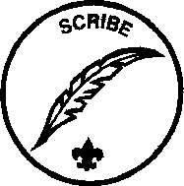
Job Title: Patrol Scribe

Level: 3
Reports to: Patrol Leader
Supervised by: Mr. McNally

Job Duties:

Keeps track of patrol attendance at every event including troop meetings and completes Honor Patrol Sheets.

Maintains a phone / email list of members in your patrol.

Sends patrol meeting minutes / emails as needed.

Submits a list of patrol members and their position after each troop election.

Sets good example by enthusiastically wearing the uniform correctly, showing Scout Spirit and living the Scout Oath and Law.

As Patrol Scribe, I promise to do my best to fulfill the requirements of this position during my term. I understand that my performance in this position will be evaluated by The Shaman Patrol and the adult leaders on the basis of my ability to complete the job based on the description above.

Scout Signature: __________________________________________________ Date: ____________________

Parent Signature: _________________________________________________ Date: ____________________

